**Experiment-10**

**Jenkins Integration with Jenkins**

**Step-1:** Start and login to Jenkins

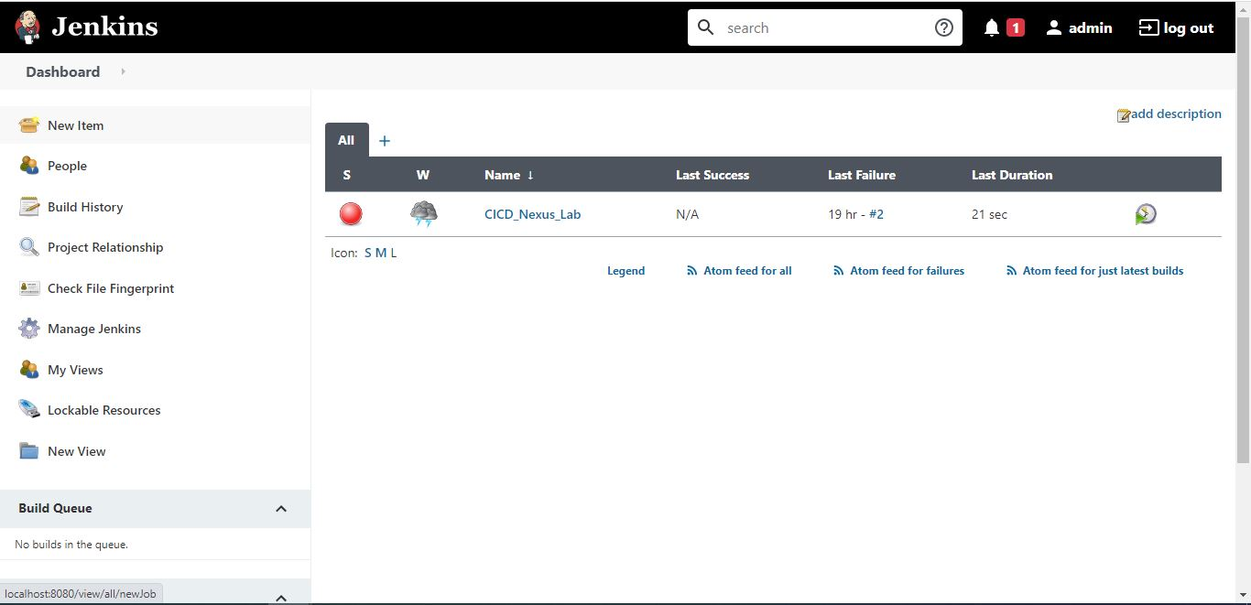

**Step-2:** Install nexus plugin

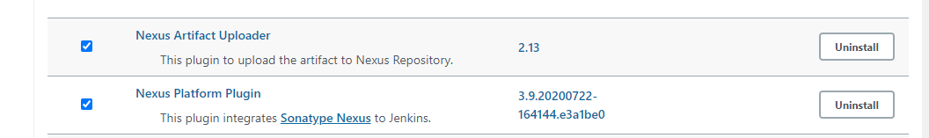

**Step-3:** Then go to global tool configuration and provide JDK 8 path

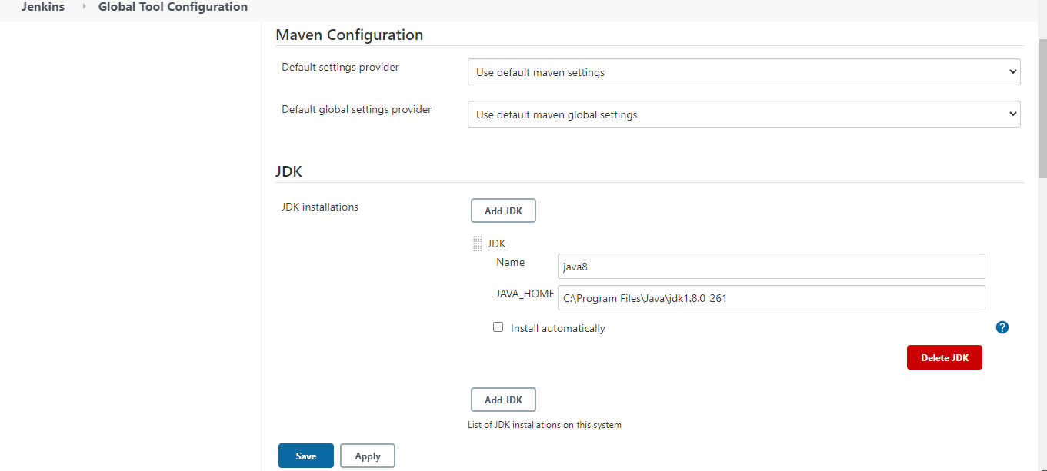

**Step-4:** Provide Sonatype nexus details in Configure System

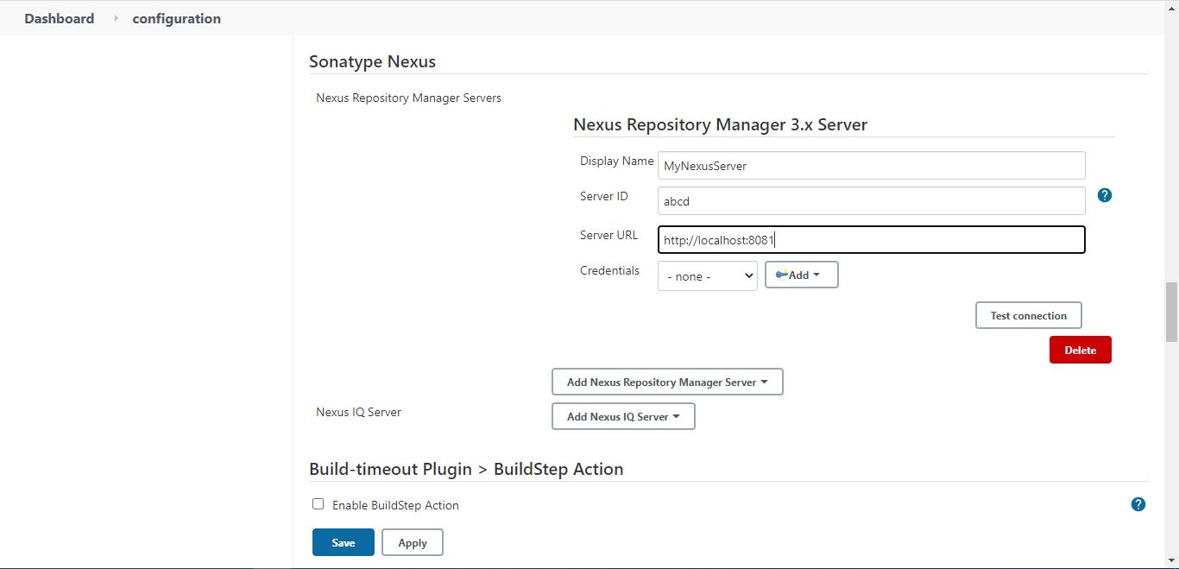

**Step-5:** Make a new Project and provide the details.

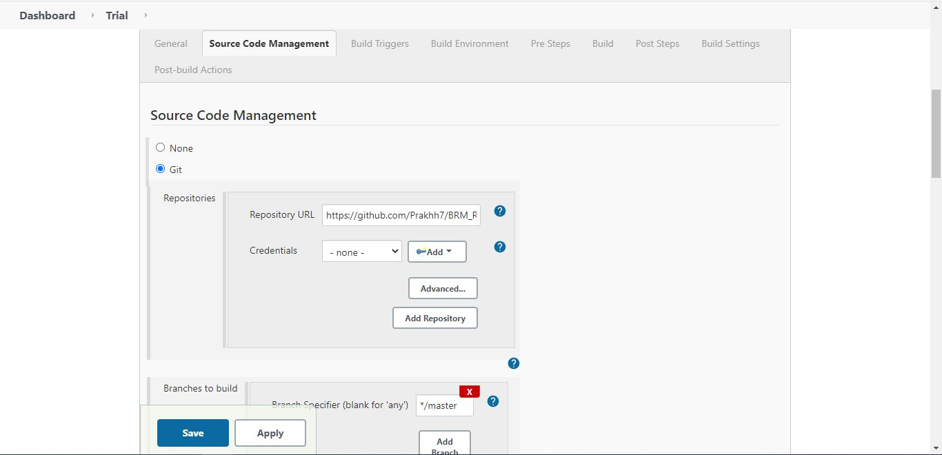

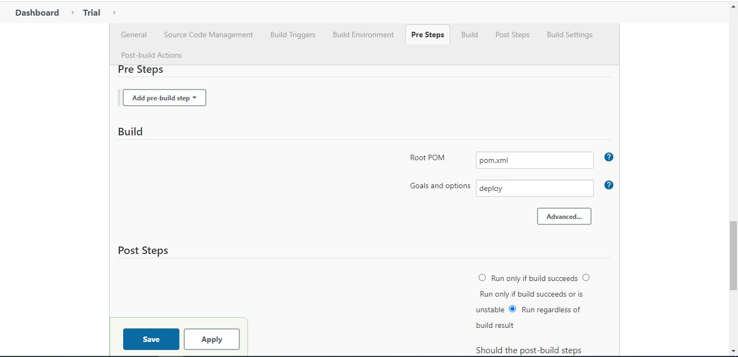

**Step-6:** Build your Project

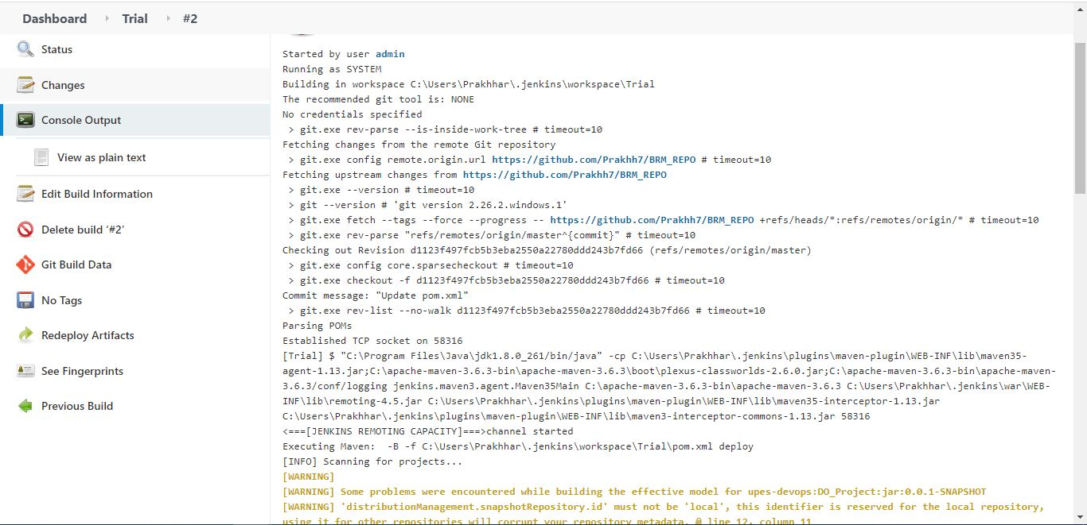

**Step-7:** Check nexus for build artifact

